Title (Times New Roman 16pt)
Author Name¹, Author Name², Author Name³
¹Institute Name, Dept. Name, City, Country name
²Institute Name, Dept. Name, City, Country name
³Institute Name, Dept. Name, City, Country name
Email¹, Email², Email³

Abstract: (Times New Roman 10pt single spacing) A supply chain is a connected system between a suppliers and company produce and allot a specific product to the end user. SC (Supply Chain) contains different activities, people, entities, information, and resources. The supply chain also characterizes the steps it takes to get the service or a product from its starting phase to the end user. Times New Roman(10pt) 150 -200 Words.
Keywords: Keyword1, Keyword2, Keyword3, Keyword4, Keyword5
- Introduction (Times New Roman 10pt Bold):
Times New Roman 10pt single spacing. Heading should be Times New Roman 10pt bold. A supply chain is a combination of a series of activities in which material moves from initial to final customers. Supply Chain Management is a methodology to maintain the flow of raw material into an organization, certain steps of the internal processing of material into finished product, and then the flow of finished product out of the organization towards the end consumers. L Wu et.al The SCM implies to have the right item in the correct volume in the correct place at the right time at the right place at the right price in the correct condition for the right customer. [16]. Taghikhahet.al. Supply chain management focuses on controlling the whole supply chain, starting with raw materials and ending with the final product delivered to the consumer [30]. According to Boone et.at. The supply chain management oversees the transportation of goods and services, which includes all procedures that transform raw materials into completed items [6]. The importance of supply chain management (SCM) is that it improves customer loyalty and productivity. According to Schniederjanset.al Agriculture, processing, design, manufacturing, packaging, and transportation all fall under the SCM umbrella.
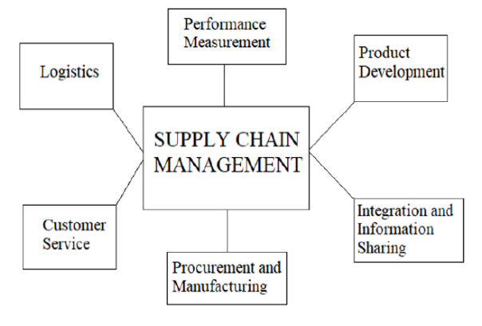
Figure 1: Functionality of Supply Chain Management
Circular Supply Chain Management - In the last few of years the circular economy and Industry 4.0 has attracted much attention, according to Theofilos D.Mastos et.al. Modern supply chains demand flexibility of supply, technique and procedures in order to boost productivity, decrease or nil waste creation, optimization of resources, and more sustainable manufacturing and consumption, etc [33]. Advanced data analytics, IoT devices, forecasting techniques, and block chain applications, among other things, are used for identify these needs. The circular economy idea has risen to the top of the corporate agenda as a result of demands from a variety of stakeholders, as well as environmental and social considerations, and businesses have realised that the creation of more sustainable practises is critical.
  - Industry Revolution
According to Sudip et al. Industry Revolution categorised in four stages [28].
Table1:
S. N. | First Industrial Revolution  (1765) | Second Industrial Revolution (1870) | Third Industrial Revolution  (1969) | Fourth Industrial Revolution  (2014)
1 | Emergence of Mechanization.  Linked Agriculture to industry. | Emergence of electrical power as new source of energy. | Rapid growth of electronics, sensors and actuators in automation systems, | Cyber physical in automation.
2 | Introduction of Steam and hydro energy  resources. | Introduction to sequential control system and mass production. | Introduce to programmable controller. | Interconnected System

  - Industry 4.0
Industry 4.0 refers to a paradigm of self-controlling and self-optimizing processes that enable businesses to provide greater levels of service by automating and digitising industrial processes using an innovative business model. Industry 4.0 enables a high level of mass customisation flexibility, emulating the time of craft production in terms of product customisation.
    - Application Areas of Industry 4.0
In present era Industry 4.0 is a booming area. Many Application areas of Industry 4.0. Some important areas are Smart Factories, Smart Product, and Smart Cities.
- Literature Review
Xue-Feng Shao et al.(2021) Smart manufacturing specify the interconnected devices, within the Cyber Physical System, in order to reach a self-evolving environment that is equipped to manage the variations and suggest the optimum alternative and direct routes. According to Tao.et.al. Smart manufacturing can accomplish tasks including all-round monitoring, production optimization and large data simulation [29].
Xue-Feng shao et.al. In order to achieve additional process efficiency and product performance, smart manufacturing uses the data acquired from the business operations [36]. In the first stage of this procedure, data from the production environment are collected. This contains information on the inputs, i.e. raw material characteristics, production variables data, machine data and human variables and, lastly, output data. The next phase in smart production is the analysis of data stored in cloud-based data centers. This constitutes the central point for further actions, such as surveillance and troubleshooting operations.

References:
- Ali Turkyilmaz, Dinara Dikhanbayeva, Zhanybek Suleiman, Sabit Shaikholla, Essam Saheb 2021.Industry 4.0:Challenges and Opportunities for Kazakhastan SMEs Procedia CIPR 96(2021) 213-218.
- Elisa Yumi Nakagawa, Pablo Oliveira Antonino, Frank Schnicke, Thomas Kuhn, Peter Liggesmeyer. Continuous Systems and Software Engineering for Industry 4.0: A disruptive view. Information and Software Technology 135106562 (2021)
- Fahimnia, B., Sarkis, J., Eshragh, A.,. A tradeoff model for green supply chain planning: a leanness-versus-greenness analysis. Omega 54, 173–190, 2015.
- Garai, A., Roy, T.K., a. multi-objective optimization of cost-effective and customer centric closed-loop supply chain management model in T-environment. Soft. Comput. 24 (1), 155–178, 2020.

